Business Requirement Document (BRD)

Packing Details Flow on Tax Invoice

1. Objective
The objective of this BRD is to display Packing Details accurately on the Tax Invoice through a structured and controlled process. The intent is to ensure that packing information flows systematically from master setup to transaction and finally to the Tax Invoice, without any manual dependency or alteration.

2. Scope
This BRD covers the functional interaction and data flow between the following modules:

- Packing BOM Master
- Packing Advice
- Dispatch
- Tax Invoice

3. Pre-Requisites (Mandatory Setup)

3.1 Packing BOM Creation
Packing BOM must be created for each Item / Finished Good.
Packing BOM will define:
- Packing Material
- Packing Quantity
- Unit of Measure (UOM)
- Packing Structure

3.2 Multiple Packing BOM (If Applicable)
- If a single item can be packed in multiple ways (e.g., domestic, export, bulk packing):
- Multiple Packing BOMs must be created.
- This will be a one-time master-level activity.
- All Packing BOMs will be maintained in the Packing BOM Master.

4. Process Flow

Step 1: Packing BOM Master
- Packing BOM is defined at the item level.
- Multiple packing options can be maintained as per business requirements.

Step 2: Packing Advice Creation
Packing Advice must be created before Dispatch.
User will select:
- Required Packing BOM / Packing Type.
- System will automatically calculate:
- Packing materials and quantities as per the selected BOM.

Step 3: Dispatch Creation
- Dispatch is created after packing.
- Packing reference is linked to the Dispatch document.

Step 4: Tax Invoice Creation (Against Dispatch)
- When a Tax Invoice is created against Dispatch:
- Packing details are auto-fetched from the Packing Advice.
- Packing details are displayed at the Line Item level on the Tax Invoice.

5. Tax Invoice Display Logic

5.1 With Packing Advice
Packing details will be displayed on the Tax Invoice line items as per the attached image.

- 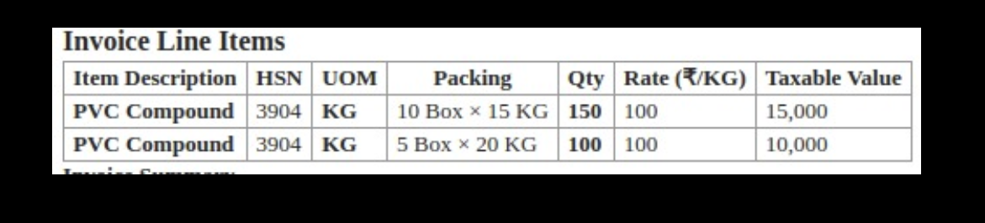
Packing material breakup and quantities will be visible.

5.2 Without Packing Advice
If Packing Advice is not created:
- Packing details will not be displayed on the Tax Invoice.
- Invoice will be generated in a simple item-level format.
- No packing material breakup or packing calculation will be shown.

6. Business Rules
Packing Advice is mandatory to display packing details on the Tax Invoice.
- Without Packing Advice: Packing cannot be created.
- Without Packing: Dispatch cannot be created.
- Without Dispatch: Packing details will not flow to the Tax Invoice.
- Packing details displayed on the Tax Invoice will be read-only.
- Manual editing of packing details will not be allowed.

7. Out of Scope
- Packing material costing
- Auto-generation of Packing BOM
- Label / barcode generation logic

8. Final Confirmation
This BRD is final.
Kindly provide your approval so that we may proceed with development and implementation.

